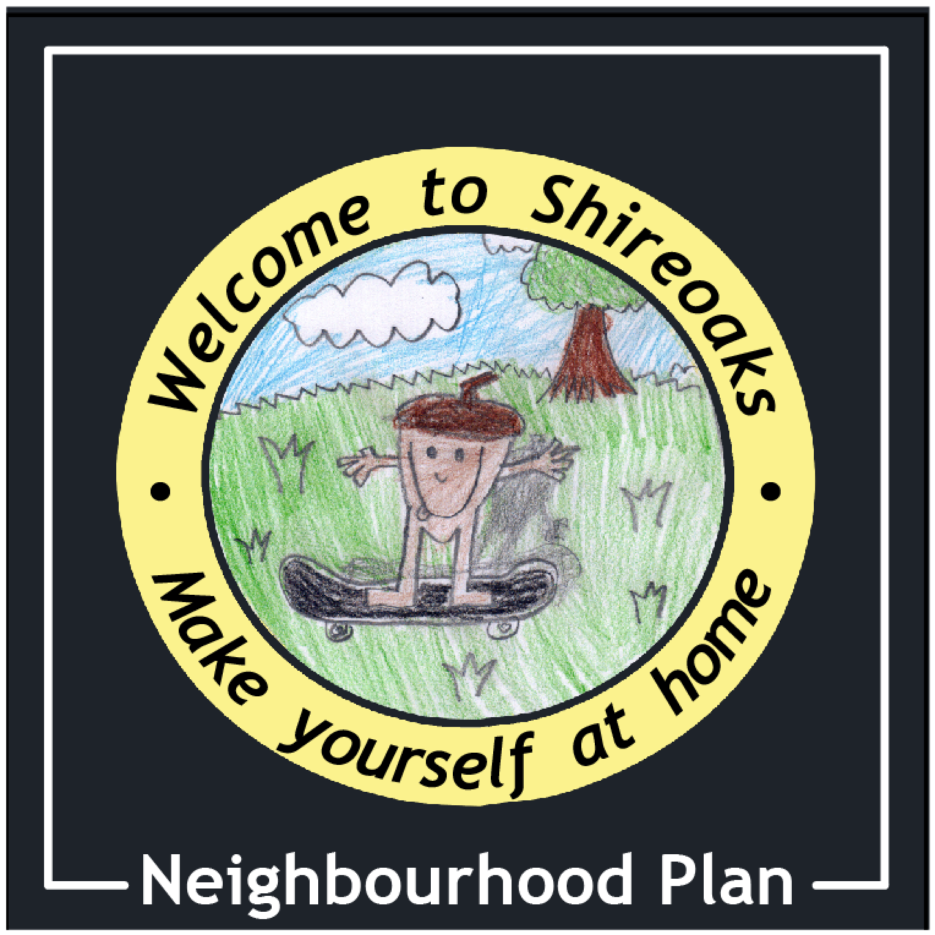  STAtutory consultation  Tuesday 26th May 2015 – Monday 13th July 2015  Give us your feedback |  |  | Shireoaks Neighbourhood Plan  Please comment in boxes below  P  Mark which projects numbers or policies you are commenting about please in below  Send to Shireoaks Parish Council  c/o 78 Shireoaks Common,  Shireoaks  S81 8PE  or email  www.shireoaksparishcouncil.f9.co.uk

Statutory Consultation Questionnaire

Name……………………………………………………… (optional)

Please comment below on any of the objectives, projects or policies enclosed in this document in this space below. Please feel free to continue on a separate sheet of paper if necessary OR simply email using the below link.
Objectives
Projects
Policies

Thank you for your interest and support. Return this page to:-
Shireoaks Parish Council, c/o 78 Shireoaks Common, Shireoaks, Notts, S81 8PE

Or send them by email to parish@shireoaksparish.f9.co.uk

DEADLINE MONDAY 13th July 2015

